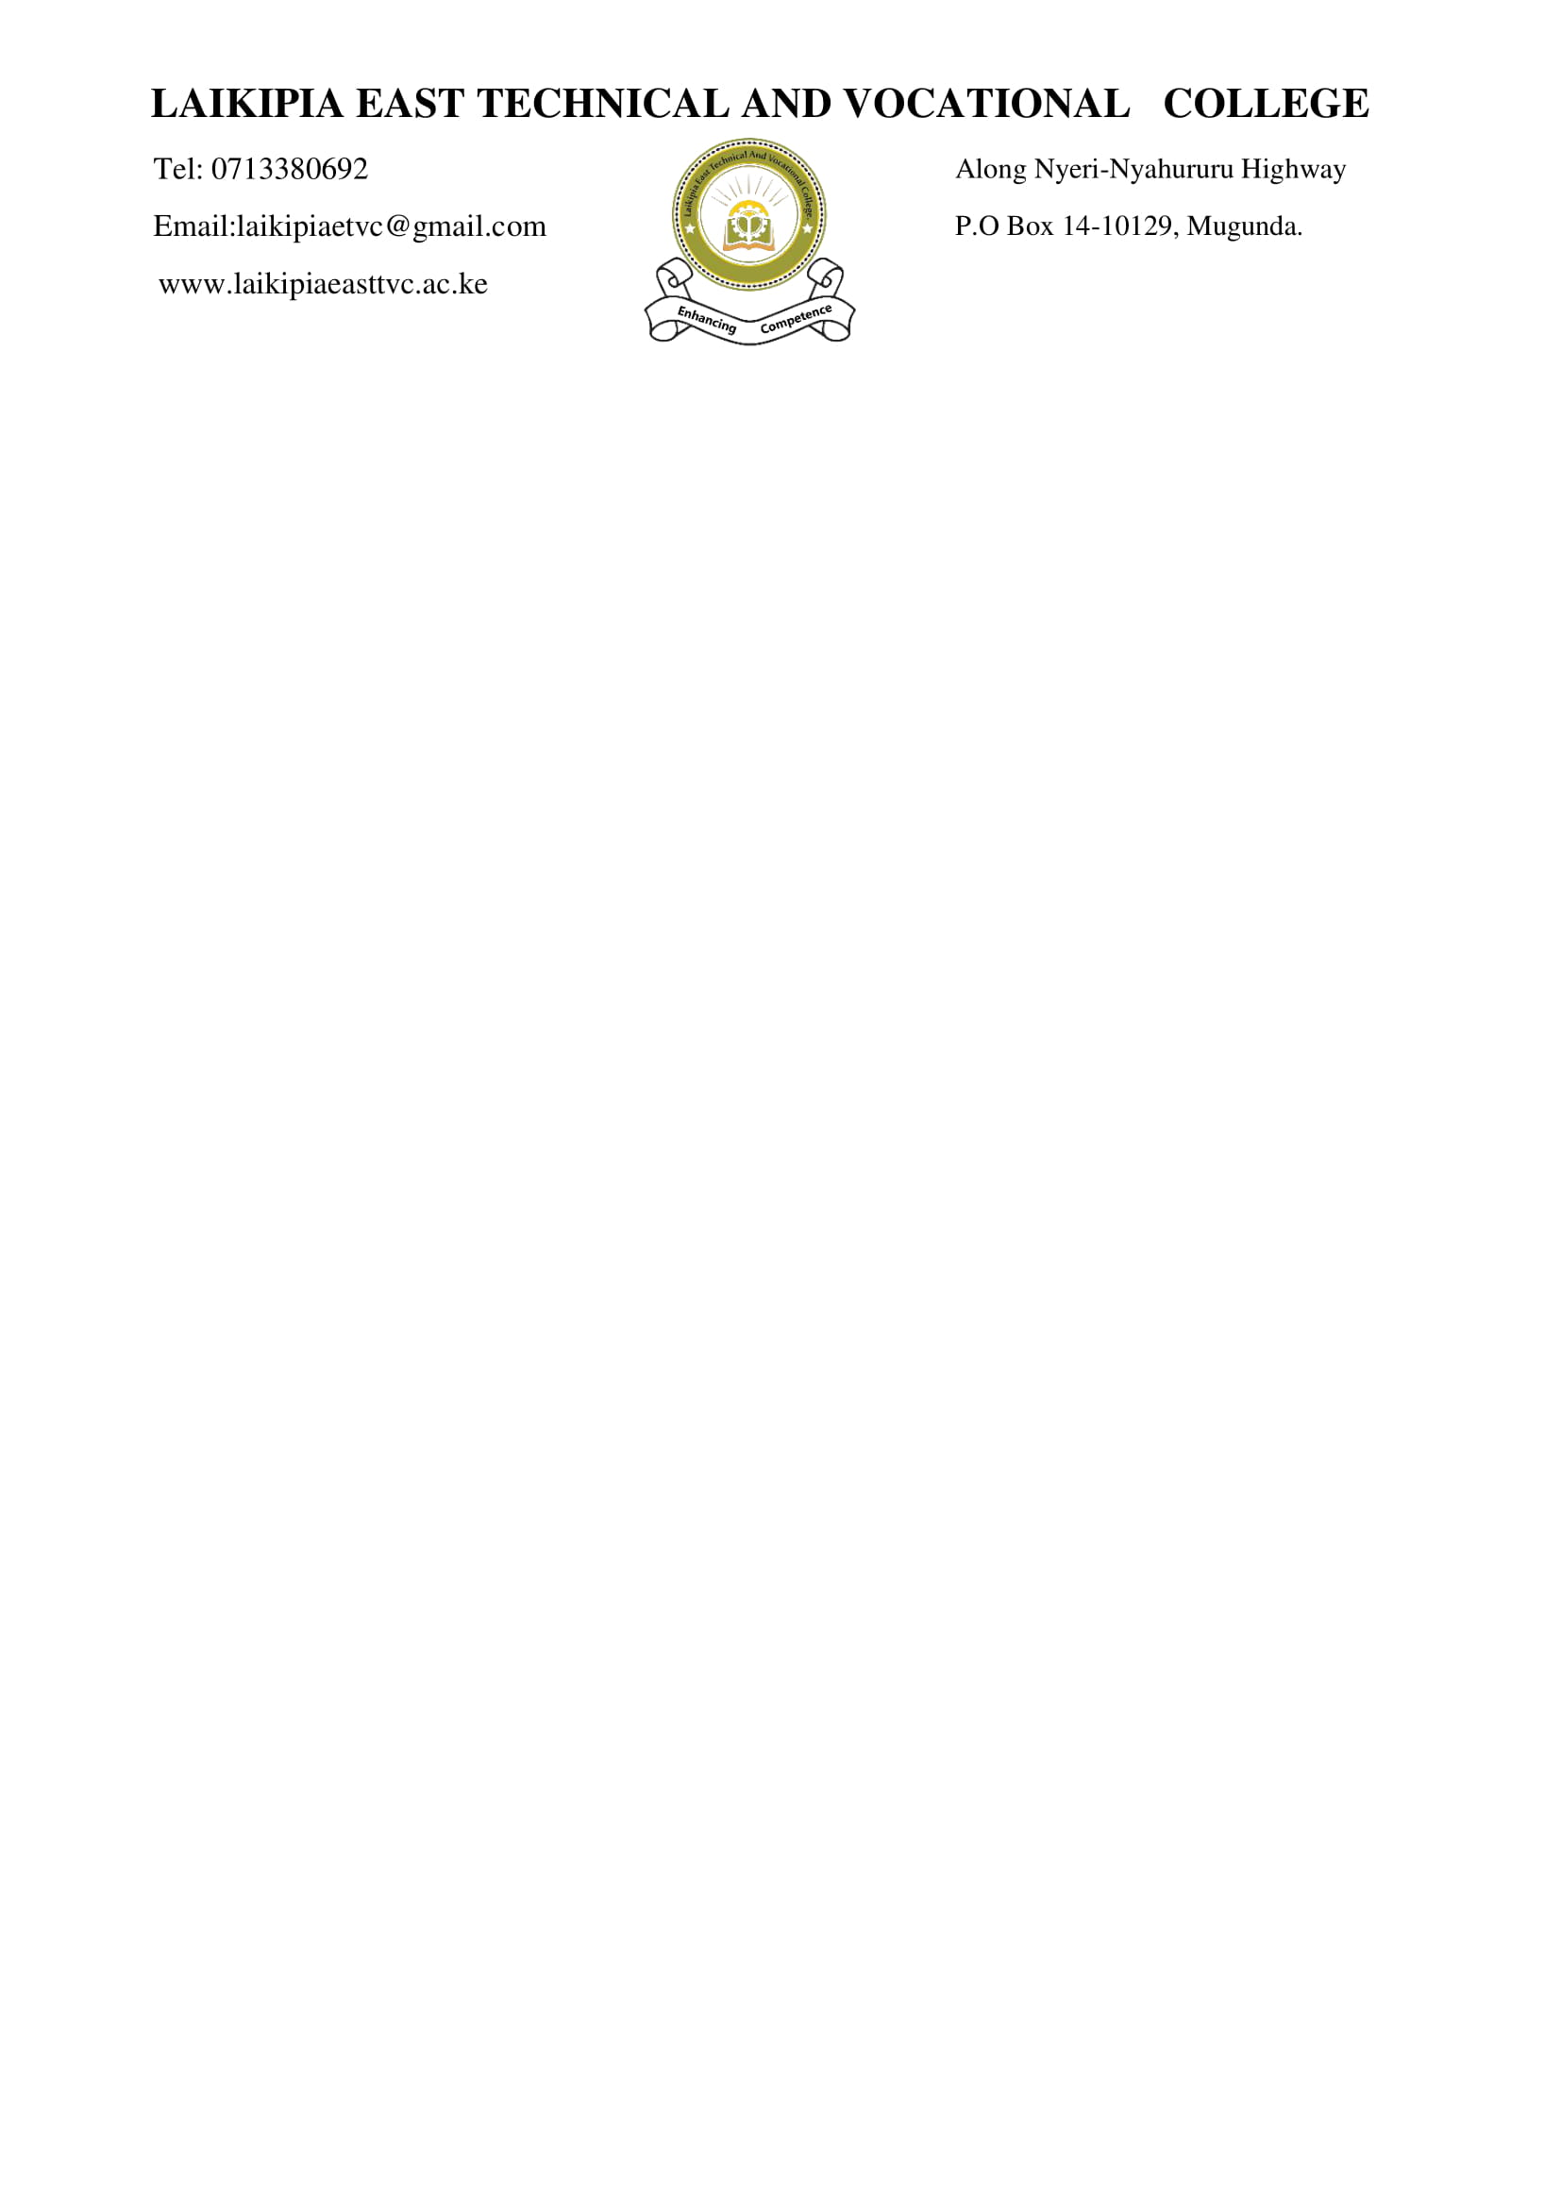

**SCHEME OF WORK (CBET CLASSES)**

|  |  |  |  |  |  |  |  |  |  |
| --- | --- | --- | --- | --- | --- | --- | --- | --- | --- |
| **DEPARTMENT: ICT** | | | | **NAME OF TRAINER: DUNCAN NDEGWA** | | | **NUMBER OF TRAINEES: 1** | | |
| **UNIT CODE: IT/CU/ICT/CR/6/6** | | | | **TERM: I** | **DATE OF PREPARATION: 27/04/2025** | | **CLASS: DICT/J25** | | |
| **COURSE: ICT TECHNICIAN** | | | | | | | **LEVEL: LEVEL 6** | | |
| UNIT OF COMPETENCE: PERFORM COMPUTER REPAIR | | | | | | | **DATE OF REVISION: 3/5/2025** | | |
| **SCHEDULE** | | | | | | | | | |
| **WEEK** | **NUMBER OF HOURS** | **ELEMENT / LEARNING OUTCOME** | **SUB -TOPIC/ CONTENT** | **SPECIFIC OBJECTIVES / PERFORMANCE CRITERIA** | | **ACTVITIES** | | **REFERENCE/ RESOURCES** | **REMARKS** |
|  | **REPORTING AND REGISTRATION** | | | | | | | | |
|  | 4 | Perform component troubleshooting | * Fault finding methods and Principles | * + Assembling of appropriate computer maintenance tools and maintenance techniques is done as per the manufacturer’s manual   + **Theory of probable cause is established**   + **Testing of the theory to determine cause is done**   + **Identification of the problem is established** | | * Taking notes * Class discussion * Questions and answers | | * E-books * Hobbs, R. (2017). *Create to learn: Introduction to digital literacy*. John Wiley & Sons. |  |
|  | 4 |  |  |  | | * Taking notes * Class discussion * Questions and answers | | * E-books * Hobbs, R. (2017). *Create to learn: Introduction to digital literacy*. John Wiley & Sons. |  |
|  | 2 |  |  |  | | * Taking notes * Class discussion * Questions and answers | | * E-books * Hobbs, R. (2017). *Create to learn: Introduction to digital literacy*. John Wiley & Sons. |  |
|  | 2 |  |  |  | | * Taking notes * Practical session * Class discussion * Questions and answers | | * E-books * Hobbs, R. (2017). *Create to learn: Introduction to digital literacy*. John Wiley & Sons. |  |
|  | 2 |  |  |  | | * Taking notes * Practical session * Class discussion * Questions and answers | | * E-books * Hobbs, R. (2017). *Create to learn: Introduction to digital literacy*. John Wiley & Sons. |  |
|  | 2 |  |  |  | | * Taking notes * Practical session * Class discussion * Questions and answers | | * E-books * Hobbs, R. (2017). *Create to learn: Introduction to digital literacy*. John Wiley & Sons. |  |
|  | 2 |  |  |  | | * Taking notes * Practical session * Class discussion * Questions and answers | | * E-books * Hobbs, R. (2017). *Create to learn: Introduction to digital literacy*. John Wiley & Sons. |  |
|  | 2 |  |  |  | | * Taking notes * Practical session * Class discussion * Questions and answers | | * E-books * Hobbs, R. (2017). *Create to learn: Introduction to digital literacy*. John Wiley & Sons. |  |
|  | 2 |  |  |  | | * Taking notes * Practical session * Class discussion * Questions and answers | | * E-books * Hobbs, R. (2017). *Create to learn: Introduction to digital literacy*. John Wiley & Sons. |  |
|  | 2 |  |  |  | | * Taking notes * Practical session * Class discussion * Questions and answers | | * E-books * Hobbs, R. (2017). *Create to learn: Introduction to digital literacy*. John Wiley & Sons. |  |
|  | **REVISION AND EXAMS** | | | | | | | | |

CHECKED BY VERIFIED BY:

NAME: NAME:

DESIGNATION DESIGNATION